 **ANNA UNIVERSITY** 

**NAAN MUDHALVAN – GUIDED PROJECT**

**DOCUMENTATION**

**FARMER INSURANCE CHAIN**

|  |  |
| --- | --- |
| DATE | 31 OCTOBER 2023 |
| TEAM MEMBERS WITH NM ID | 1. ASWIN KRISHNA M –   93A42A8D371667AB4A04EAAC81B6B402   1. BHARATHI R - EA3E07A3A89131DA782474D19C6F8249 2. BOOPATHI J- FEBCCCA7D2B925CB9D24C6BDAF4CB1AE 3. DEEPAK K - 8F31A2F3B69C15BB1AA4A19BACAD94F6 4. VINOTH P- 3B7F07DDBB06A4ABF8B47C6AAB51207F |
| PROJECT NAME | FARMER INSURANCE CHAIN |
| COLLEGE NAME | ALAGAPPA COLLEGE OF TECHNOLOGY, ANNA UNIVERSITY |

**INTRODUCTION:**

**BLOCKCHAIN:**

Blockchain is like a digital ledger that records transactions across multiple computers in a secure and transparent way. It's the tech behind cryptocurrencies, but its applications go beyond that to areas like smart contracts and decentralized apps.

**1.1 Project Overview:**

Introducing Farmer Insurance Chain, a ground breaking application of blockchain technology tailored for the agricultural sector. Cultivating a decentralized ecosystem, this innovative platform ensures transparency, efficiency, and security in insurance transactions for farmers. Embrace the harvest of trust and resilience with Farmer Insurance Chain in the era of blockchain empowerment. Un-earth the potential of smart contracts within Farmer Insurance Chain, streamlining claim processes and reducing administrative overhead. This blockchain subtopic not only fortifies risk management but also establishes a traceable, tamper-resistant ledger for agricultural insurance. Join the revolution as Farmer Insurance Chain Plows through conventional barriers, fostering a resilient future for farmers through the fertile grounds of blockchain technology.

**1.2 Purpose:**

The Farmer Insurance Chain project aims to revolutionize the agricultural insurance landscape by leveraging blockchain technology. Its primary purposes include:

**Transparency:** Establishing a transparent and immutable ledger ensures that all stakeholders have real-time access to accurate data, fostering trust in insurance processes.

**Efficiency:** Utilizing smart contracts automates and expedites claim settlements, reducing paperwork and administrative delays, ultimately providing farmers with quicker access to financial support.

**Decentralization:** By decentralizing insurance processes, the Farmer Insurance Chain mitigates the risk of a single point of failure, enhancing the resilience and reliability of the overall system.

**Traceability:** Creating a traceable record of transactions ensures that the history of policies, claims, and payments is easily auditable, enhancing accountability across the insurance network.

**Access to Financial Services:** Facilitating a more accessible and efficient insurance platform can empower farmers.

**LITERATURE SURVEY:**

**Adoption:** Despite the potential benefits, widespread adoption of blockchain technology in the agricultural insurance sector is hindered by a lack of awareness, understanding, and infrastructure.

**Data Standardization:** Inconsistencies in data formats and standards across various agricultural entities pose a challenge to creating a unified and interoperable blockchain solution for insurance.

**Scalability Concerns:** As the number of transactions and participants increases, scalability becomes a concern. Ensuring that the blockchain network can handle the volume of insurance transactions in the agricultural sector is crucial.

**Integration with Traditional Systems:** Integrating blockchain solutions with existing insurance infrastructure and regulatory frameworks requires careful navigation to ensure a seamless transition without disrupting established processes.

**Regulatory Compliance:** Navigating the complex regulatory landscape in different regions and countries poses a challenge. Adhering to existing insurance regulations while leveraging the benefits of blockchain technology requires a delicate balance.

**Data Privacy and Security:** While blockchain provides enhanced security, ensuring the privacy of sensitive farmer and insurance data remains a paramount concern, especially given the decentralized nature of the technology.

Blockchain technology can revolutionize the farmer supply chain by providing transparent, tamper-proof records of transactions. This ensures traceability, reduces fraud, and enhances trust among stakeholders. Smart contracts on blockchain can automate processes, improving efficiency in procurement, distribution, and payment. Consider exploring case studies or specific applications to illustrate these points in your report.

**2.2 Reference:**

|  |  |  |
| --- | --- | --- |
| **S. No.** | **Literature** | **Author** |
| **1** | Blockchain Basics: A Non-Technical Introduction in 25 Steps | Daniel Drescher |
| **2** | Mastering Bitcoin: Unlocking Digital Cryptocurrencies | Andreas M. Antonopoulos |
| **3** | Blockchain Revolution: How the Technology Behind Bitcoin and Other Cryptocurrencies is Changing the World | Don Tapscott and Alex Tapscott |
| **4** | The Basics of Bitcoins and Blockchains | Antony Lewis |
| **5** | Blockchain Applications: A Hands-On Approach | Arshdeep Bahga and Vijay Ma |

**2.3Problem Statement :**

Agriculture is risky. Indeed, the exposure to a wide variety, complexity, and scale of risks can make it one of those rare activities where the risks are too high and the rewards too low, especially for smallholder farmers.

The many risk classes agriculture is exposed to, especially rain-agriculture, which, naturally, is more vulnerable to the risk of too much or too little rainfall. In addition, extreme weather, though perhaps rare, can frequently cause catastrophic losses. Farmers’ exposure to weather risks also varies significantly with the choice of crops. Every crop requires watering at various stages of planting, tilling, heading, and ripening. Crop output is significantly reduced when water is insufficient or excessive during each of these phases. Pest infestations are more likely during heading and ripening and are generally less severe, but in rare cases can damage an entire crop. In addition, infestation can be localized or widespread depending upon a crop’s vulnerability to pests. Pest resistant seeds and pesticides can be helpful, but in some cases become ineffective. High use of pesticides, meanwhile, is connected to non-communicable diseases such as cancer. Water and soil quality also impact agricultural output. Groundwater or surface water that is contaminated by industrial effluents and pollutants undermines the quantity and quality of agricultural output. In addition, indiscriminate use of chemical fertilizers that do not match with the soil conditions can be detrimental to the crop yields and, although occurring with low to medium frequency and severity, can become more severe if ignored.

The risk involved in situations that present the opportunity for loss but no opportunity for gain. Pure risks are generally insurable. The risk where neighbouring households in a locality suffer similar shocks such as rainfall and market price conditions. The risk where one household’s experience is unrelated to neighbours such as field specific problems, a disease that affects a household member. The risk involved in situations that present the opportunity for loss or gain. Speculative risks are generally not insurable. The risk involved in situations where the chance a business’s cash flows are not enough to pay creditors and fulfil other financial responsibilities. Risk that arises as a result of organizational change.

Source: Insurance Glossary, International Risk Management Institute.

Input and output price volatility is one of the subtler yet equally precarious risks farmers face. It is one of the few speculative risks and, as such, has an up and downside, that is, it can operate in the farmer’s favour. Uncertain price movements of inputs such as seeds, fertilizers, and pesticides, on one hand, and the final output on the other, can disturb a farmers’ margin estimations, affecting profitability. This risk is particularly high for smallholder farmers, as they enjoy no benefits of scale on procurement or sales. Theoretically, price volatility arises because of demand and supply factors. But in practice, frequently, it results from active manipulation by cartels of large traders or processors. Management of speculative risks is more complicated and agriculture markets. depends more on the level of regulation and efficiency in the Agricultural credit is always in high demand from smallholders. Access to credit by small farmers from formal institutions such as banks has remained a challenge. The microfinance sector filled the gap to some extent in some countries, but informal lenders nonetheless still control a large part of the agriculture credit market. More often, these moneylenders are a part of the agriculture value chain on the farmer’s demand or supply side. From the farmer’s perspective, the risk arises on two counts. First, the limited credit supply from formal financial institutions makes credit availability a big uncertainty. Changes in the credit policies of these institutions also affect farmers’ eligibility to credit. Second, informal credit is often exorbitantly expensive. Here the risk is about the rate of interest, the repayment terms, and the resultant effect on farmers’ profitability. Most smallholders rely on family for labour, indeed, the cost savings often become the effective profit margin, and it is crucial for the farmer to deploy all family members during the peak season. When the model is so tight, sickness or death in the family not only results in additional health or last-rite expenses, but also hiring outside labour, can wipe out a farmer’s margins. Despite this, farmers pay little attention to these factors, exposing themselves to this rare but financially severe risk. Agriculture as a sector is also highly vulnerable to political developments. In most jurisdictions, agriculture enjoys subsidies at various levels of the value chain and any change in the structure of subsidies because of the fiscal or political situation can have a big impact on fortunes. The diversity of all these risks makes agriculture unique. Practically speaking, weather seems to be the only class of risk that can inflict catastrophic losses. Severity for all other risks varies from low to medium, with a remote chance of very high financial impact. That said, because all categories of risk are independent of each other, their cumulative severity can often become devastating. Moreover, frequency makes things more complex. Almost all risks have the propensity to strike with medium or high frequency. Typically, prevention or control is the best strategy for handling high-frequency risks. But here we have a situation that, apart from biological risks that can be controlled through better farm management, almost all other risks are beyond individual control. It is this tricky combination of frequency and severity, coupled with the uncontrollable nature of most risks, that makes agriculture a high-risk business. Yet, the rewards are quite modest, especially for smallholders operating without economical volumes. Even if risks do not strike, market distortions and logistical issues most often preclude the farmer from getting the best price for his produce, keeping him hand to mouth even after a good harvest. This skewed risk-reward equation makes agriculture an unviable activity for many small farmers. Indeed, the rural exodus and distress in many parts of the developing world largely reflects this failure to cope with the repeated impact of risks of agriculture, and people thus decide to take up paltry alternative employment in cities or resort to extreme actions such as suicide.

**IDEATION & PROPOSED SOLUTION:**

**3.1 Empathy Map Canvas:**

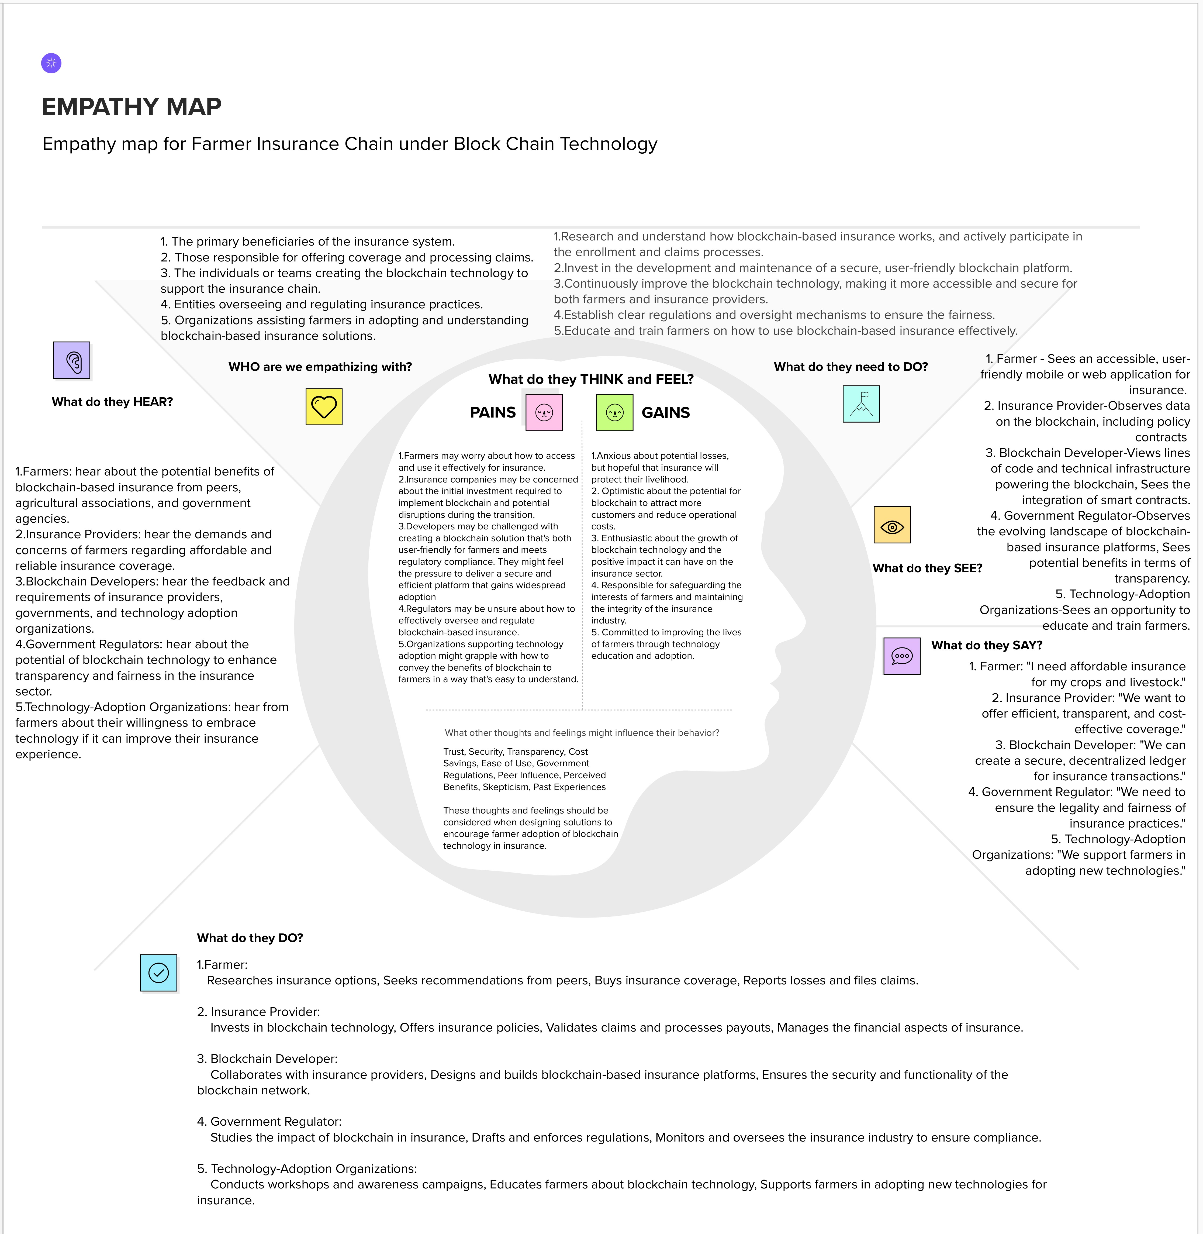

**3.2 Ideation & Brainstorming:**

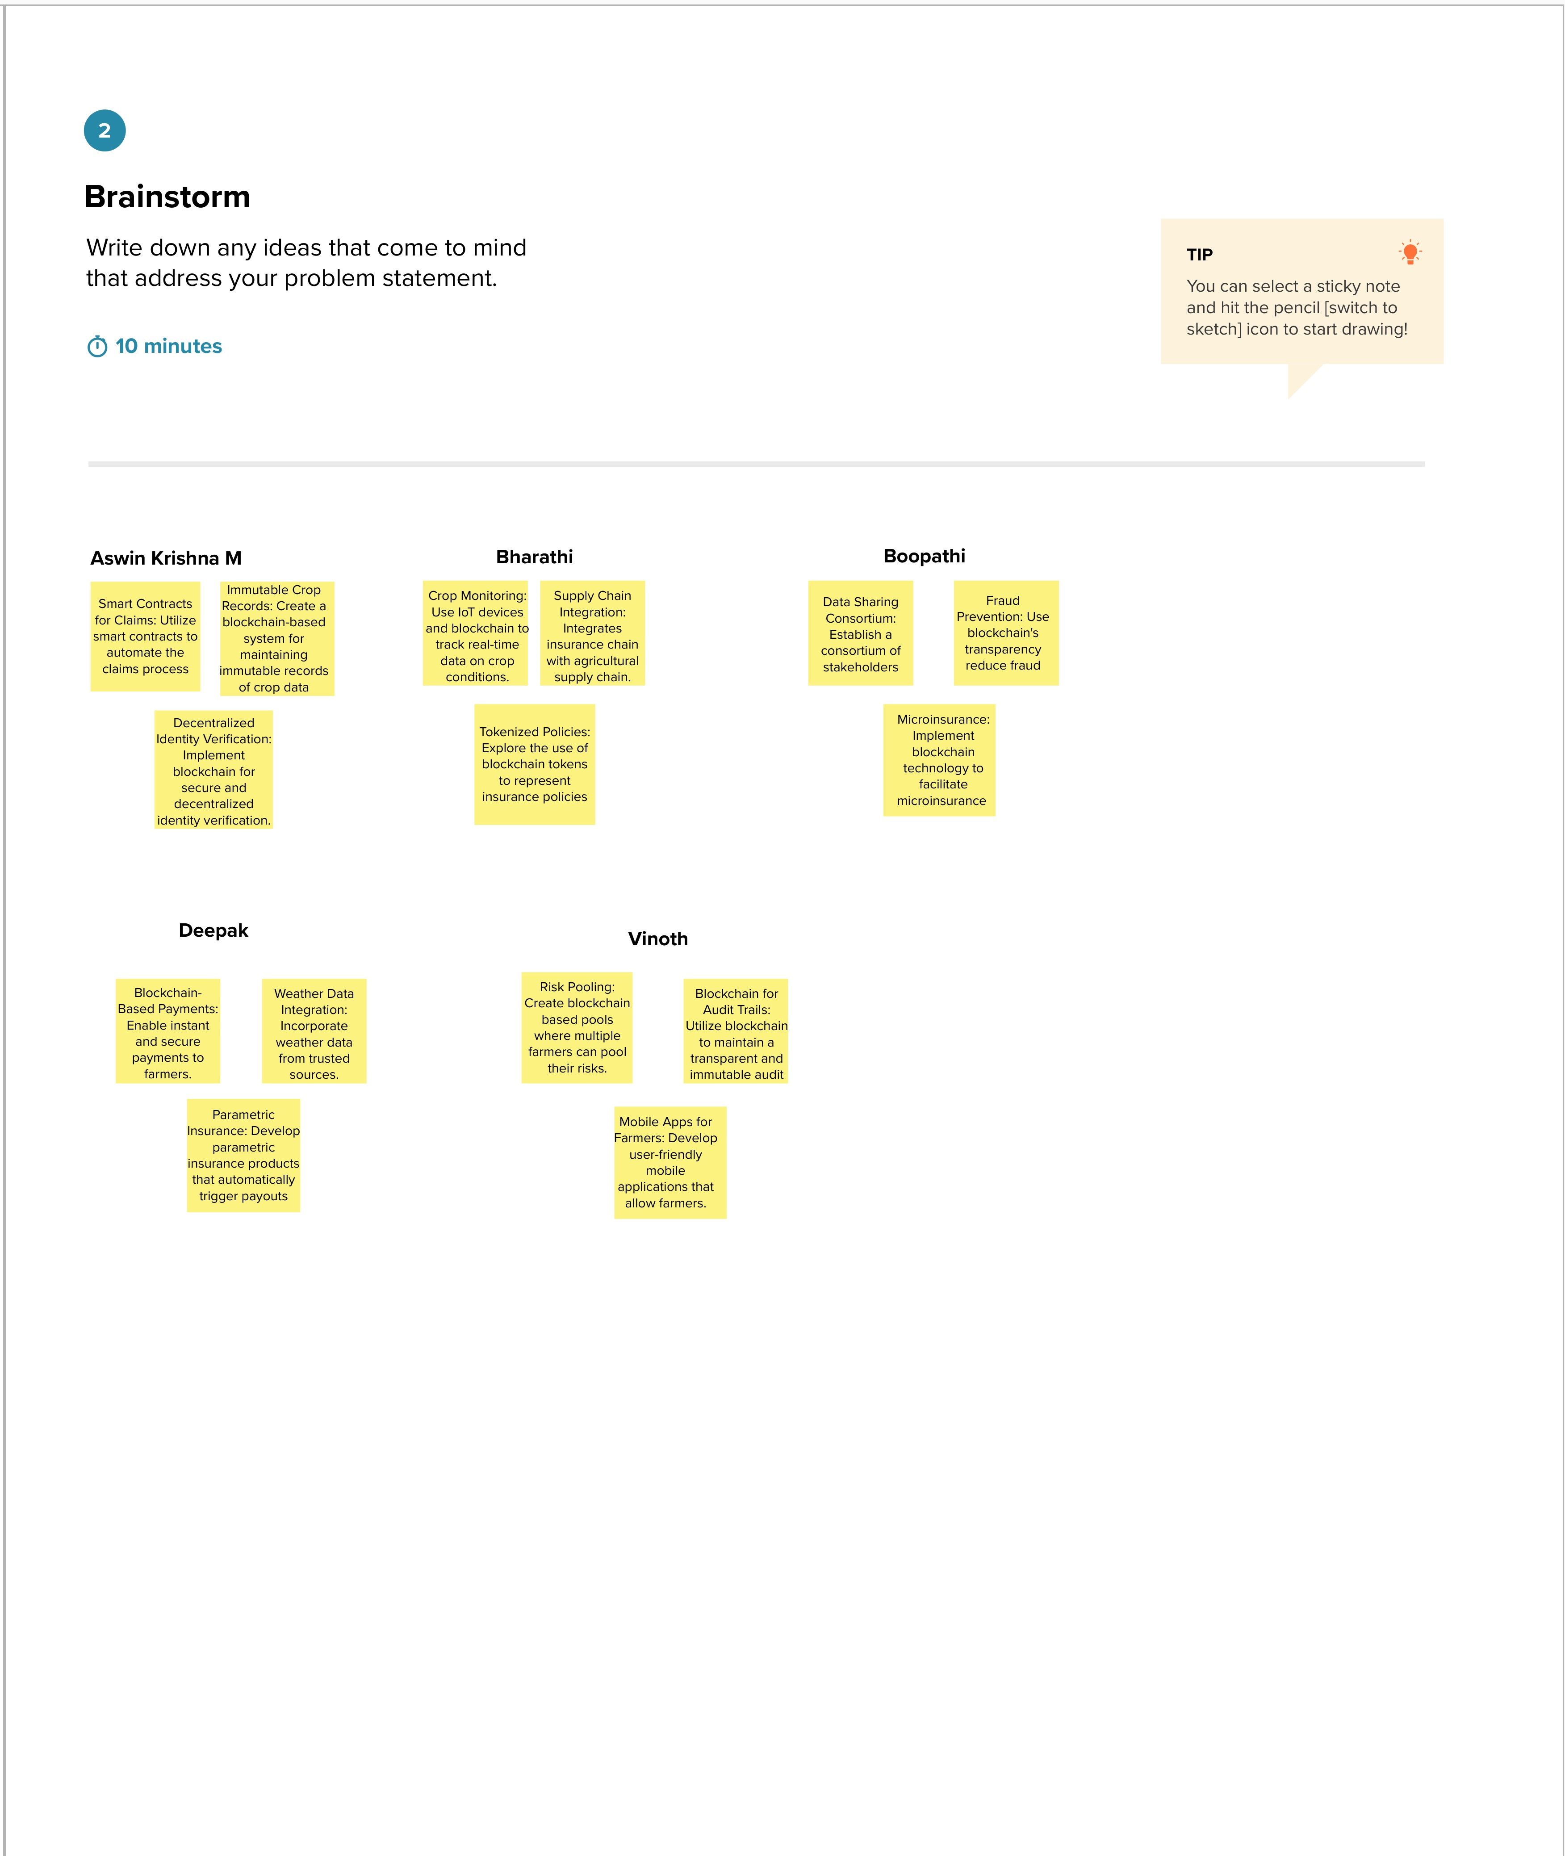

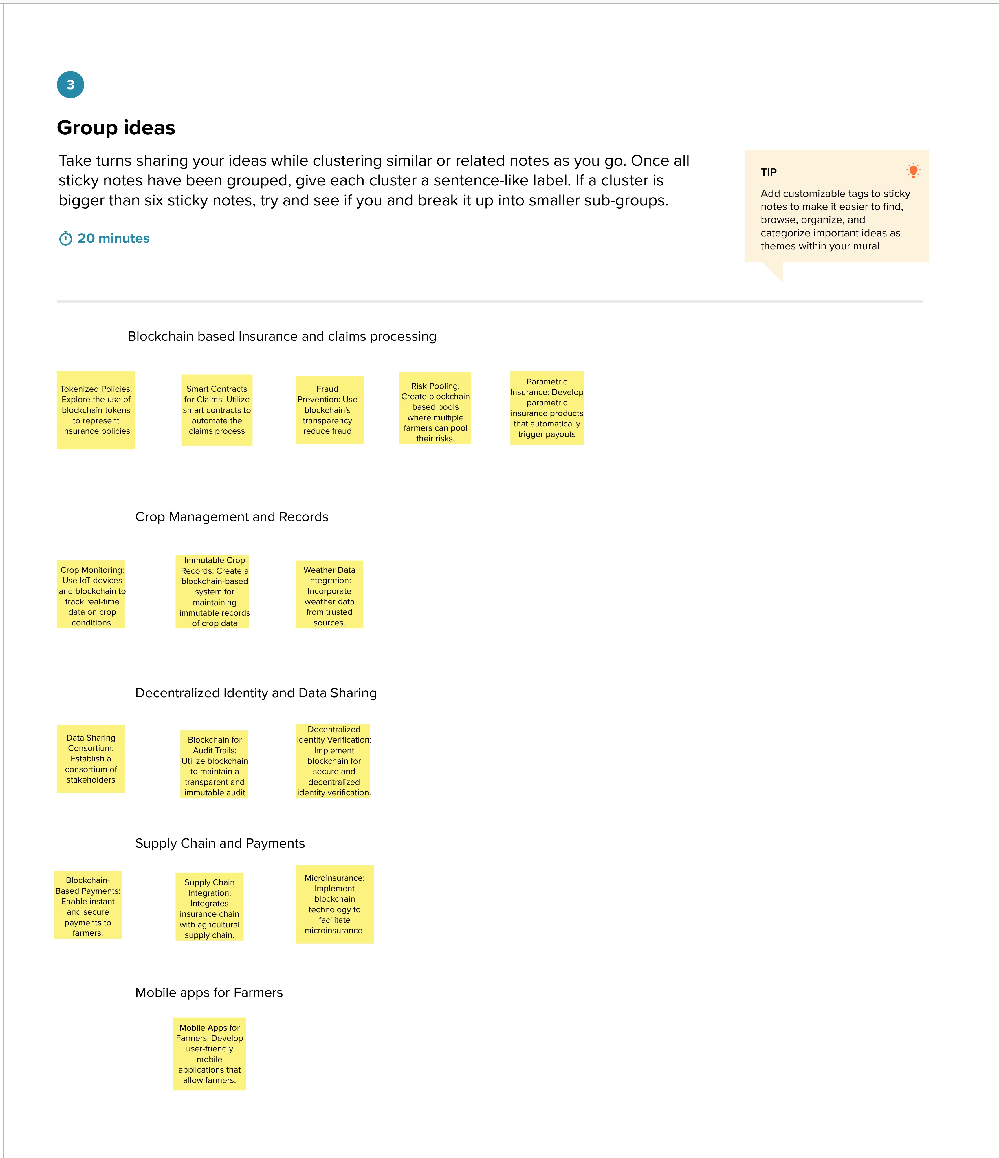

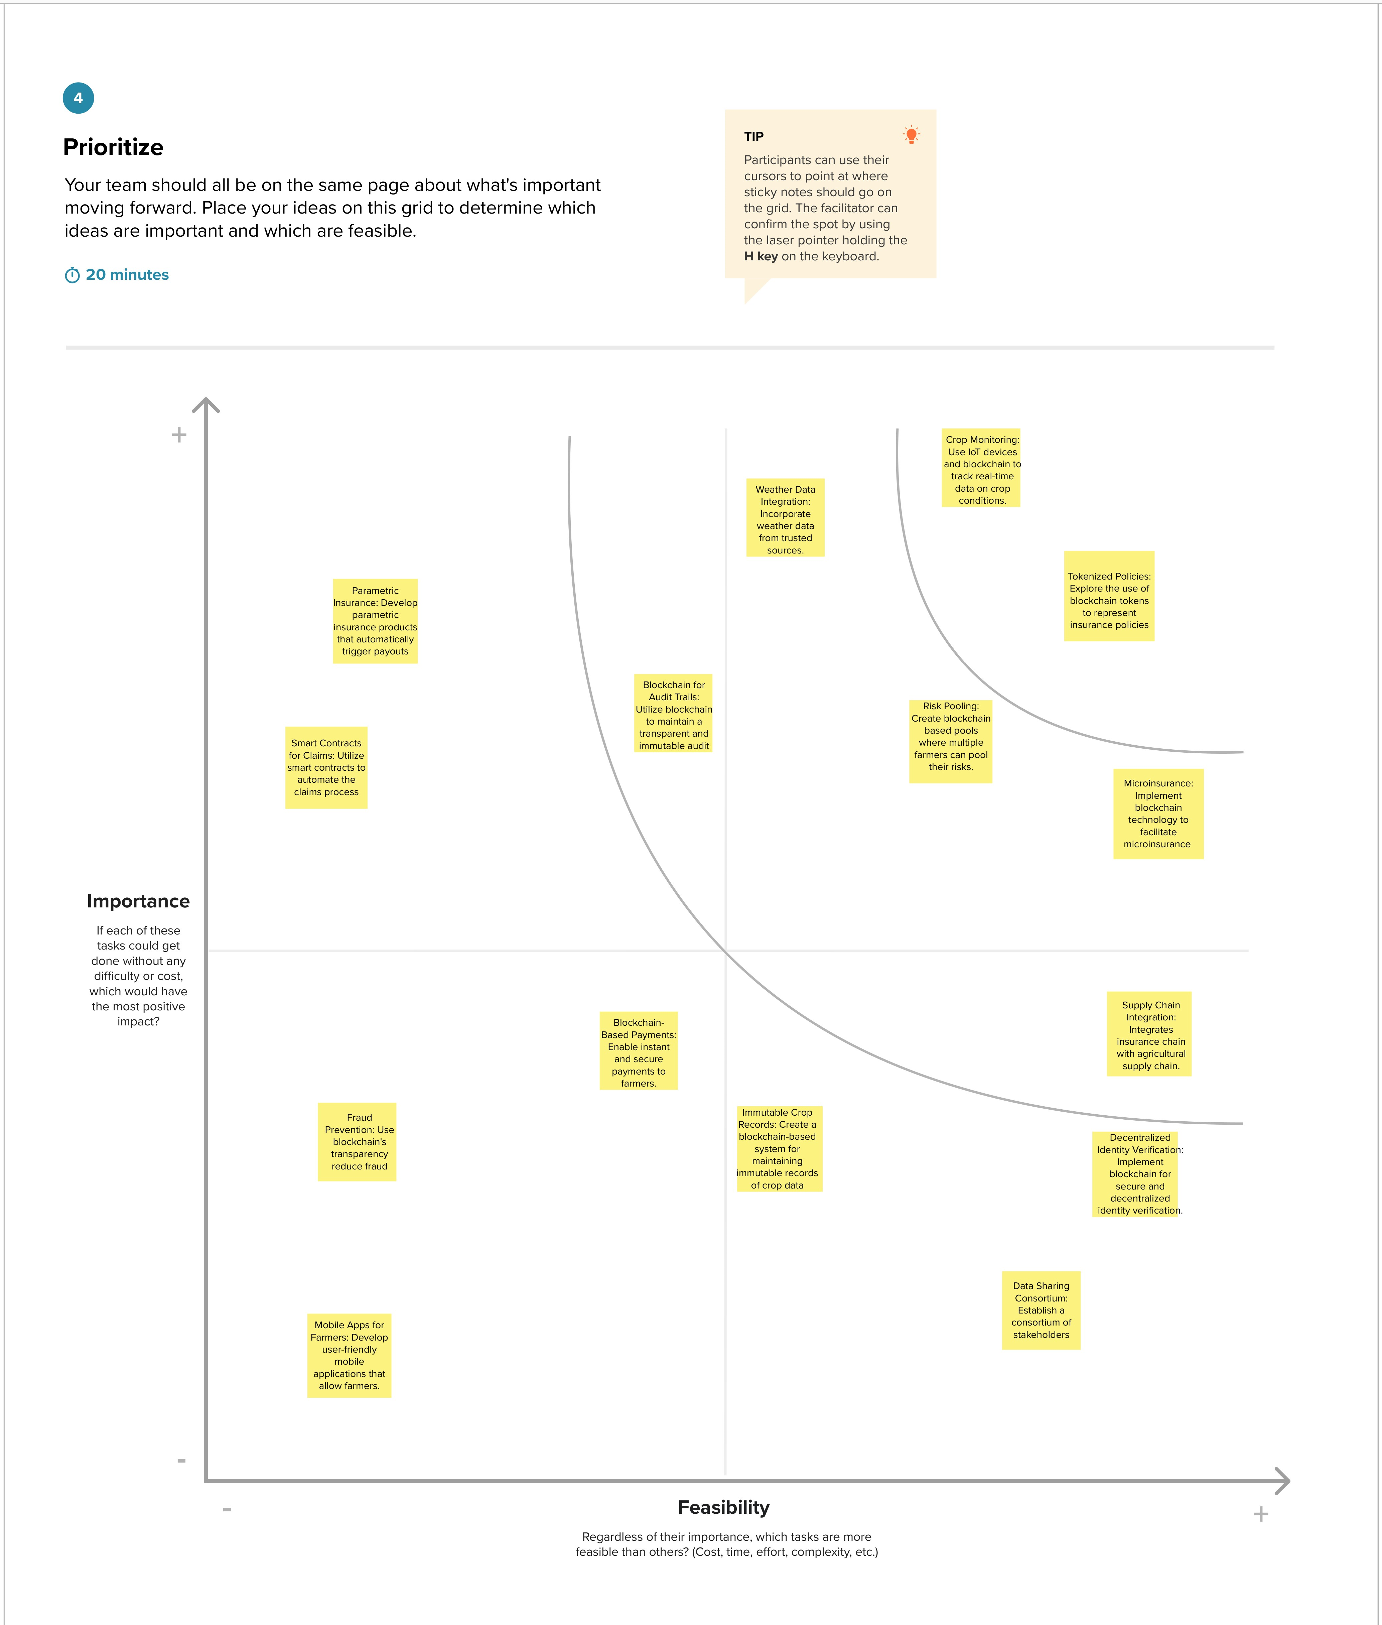





**REQUIREMENT ANALYSIS:**

**4.1 Functional requirements:**

The functional requirements of this project are Visual Studio Code, one remix id platform (node.js connector), file explorer, meta mask chrome extension and a source code file.

Drive link of the source code: <https://drive.google.com/drive/folders/10VGbch-kHhUKk1oQJevdqOmsvNeqaQN6>

**4.2 Non-Functional requirements:**

**Non-functional requirements** are essential considerations for any blockchain project, including one focused on farmer insurance. These requirements ensure that the system functions effectively and meets the needs of its users. Here are some non-functional requirements for the "FARMER INSURANCE CHAIN" project:

**1. Security:** Data Encryption: Ensure all data on the blockchain is encrypted to prevent unauthorized access. Access Control:Implement robust access control mechanisms to protect sensitive information. Immutable Data:Data stored on the blockchain should be tamper-proof and immutable.

**2. Scalability:** The system should be able to scale to accommodate a growing number of farmers and policies without compromising performance.

**3. Performance:** The blockchain should provide fast transaction processing to support real-time insurance claims and policy management. The system should have minimal downtime to ensure continuous availability.

**4. Privacy:** Implement privacy features to protect farmers' personal and financial information. Ensure that only authorized parties can access specific data on the blockchain.

**5. Compliance**: Ensure compliance with local and national regulations related to insurance and data protection.

**6. Interoperability:** The blockchain should be compatible with existing insurance systems and databases to facilitate data exchange and integration.

**7. User Experience (UX):** The user interface should be intuitive and easy to use for farmers, insurance providers, and administrators. Ensure responsiveness and a seamless user experience, even during high traffic.

**8. Auditability:** Implement features that allow for auditing and tracing of transactions and changes to the blockchain.

**9. Fault Tolerance:** The system should be designed to withstand network and hardware failures and continue functioning without data loss.

**10. Consensus Mechanism:** Choose an appropriate consensus mechanism (e.g., Proof of Work, Proof of Stake, or a custom consensus algorithm) that aligns with the project's goals and performance requirements.

**11. Regulatory Compliance:** Ensure that the blockchain complies with any relevant legal and regulatory requirements in the insurance industry and the jurisdictions where it operates.

**12. Data Backup and Recovery:** Regularly back up blockchain data to prevent data loss in case of system failure or disasters .Implement a robust data recovery plan.

**13. Environmental Impact:** Consider the environmental impact of the blockchain's consensus mechanism, especially if it involves resource-intensive processes like mining. Strive to minimize the carbon footprint.

**14. Sustainability:** Plan for long-term sustainability by addressing issues like network maintenance, upgrades, and support.

**15. Documentation and Training:** Provide comprehensive documentation for users and administrators. Offer training and support resources for all stakeholders to ensure they can effectively use the blockchain.

These non-functional requirements are essential for ensuring the success, security, and performance of the "**FARMER INSURANCE CHAIN**" project. They should be considered alongside the functional requirements when designing and implementing the blockchain solution.

**PROJECT DESIGN:**

**5.1 Data Flow Diagram & User Stories**

Characteristic of blockchain technologies:

Some key characteristics of blockchain technologies are listed as follows:

* **Increased capacity:** Blockchain technology can increase the capacity of an entire network. One such example is the supercomputer created by Stanford University used for medical research.
* **Better security:** Blockchain technology offers better security as it provides for a network of numerous computer nodes that can be used for networking transactions .
* **Immutability:** Blockchain uses immutable ledgers, and all databases require trust of a third party to keep them secure from hackers. Blockchain applications, such as Bitcoin, maintain the ledger in a never-ending state of forward momentum.
* **Faster settlement:** Blockchain technology relies on faster speeds and saves time for institutions and consumers. One example from banking is that blockchain makes money transfer fast and convenient.
* **Decentralized System:** Blockchain technology offers a decentralized system that stores the assets in a network and can be accessed via the internet. The asset may be a contract or document of importance. The manager of blockchain technology has control over the accounts of individuals and can transfer anything to anyone. This technology is proving to be an effective tool for decentralizing the web.
* **Minting:** Blockchain technology involves minting a problem in several ways. Proof of work is one approach guaranteeing an individual is engaged in a significant amount of computation work.

**5.1.1 Data Flow Diagram**

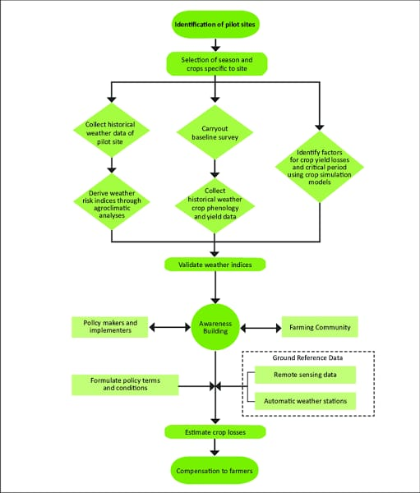

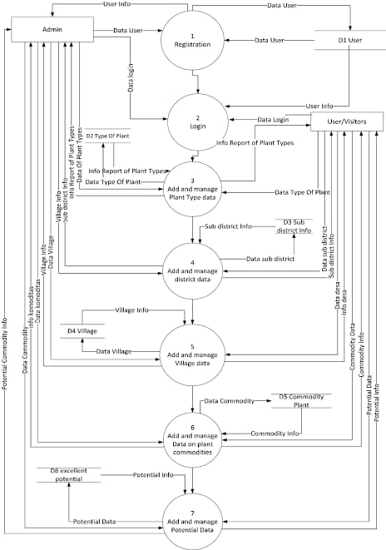

Source Data flow diagram

**5.1.2 User Stories:**

User stories help describe the functionality from the perspective of different users. Here are some user stories for the Farmer Insurance Chain project:

* As a farmer, I want to register on the blockchain platform to access insurance services easily.
* As a farmer, I want to view and compare insurance policies from different companies to choose the one that suits my needs.
* As a farmer, I want to purchase an insurance policy online, and the blockchain should record the transaction securely.
* I want to submit a claim in case of crop damage or loss due to natural disasters, pests, or diseases.
* I want my submitted claim to be verified quickly and transparently through smart contracts on the blockchain.
* As an insurance company, I want to create and manage insurance policies for farmers, with policy terms and premium calculations stored on the blockchain.
* As an insurance company, I want to receive premium payments from farmers securely through the blockchain.
* As a government agency, I want to access data on insured farmers and their policies for subsidy disbursement purposes.
* As a government agency, I want to disburse subsidies to eligible farmers through the blockchain.
* As a blockchain administrator, I want to ensure the security and integrity of the blockchain network and handle any necessary updates or maintenance.

These user stories should guide the development of the Farmer Insurance Chain project and help in creating a user-centric and efficient system for farmers, insurance companies, and government agencies. The DFD provides a visual representation of how data and processes are interconnected in the system.

**5.2 Solution Architecture:**

Implementing a blockchain solution for farmer insurance can bring transparency and efficiency to the process. Here's a high-level overview of how it can work**:**

**1. Smart Contracts**: Develop smart contracts on the blockchain to automate insurance policies. These contracts can self-execute when predefined conditions are met, reducing the need for intermediaries.

**2. Identity Verification:** Use blockchain to securely verify the identity of farmers, preventing fraud and ensuring that only eligible farmers are insured.

**3. Data Sharing**: Create a decentralized database where relevant data (crop information, weather data, insurance claims) is stored securely. Access to this data can be permissioned and auditable.

**4. Tokenization:** Issue tokens that represent insurance policies. These tokens can be easily traded and transferred, allowing for more flexibility and liquidity in the insurance market.

**5. Immutable Records:** Once data is written to the blockchain, it cannot be altered, ensuring the integrity of records, which is crucial for insurance.

**6. Decentralized Claims Processing**: Claims can be automatically processed based on predefined criteria, reducing the time and cost associated with traditional claims processing.

**7. Payment Automation:** Smart contracts can automatically trigger payments to farmers when claims are approved, eliminating delays and disputes.

**8. Marketplace:** Create a blockchain-based marketplace for insurance policies, allowing farmers to compare and purchase policies from various providers.

**9. Data Feeds:** Integrate real-time data feeds for weather, crop conditions, and other relevant factors to trigger events in smart contracts.

**10. Regulatory Compliance**: Ensure that the blockchain solution complies with local insurance regulations and data protection laws.

**11. User-Friendly Interfaces:** Develop user-friendly apps or platforms for farmers and insurance providers to interact with the blockchain.

**12. Security:** Implement robust security measures to protect sensitive data and prevent unauthorized access.

It's important to work closely with farmers, insurance providers, and regulators to ensure that the blockchain solution meets their needs and complies with relevant regulations. Additionally, blockchain implementation should address scalability and environmental concerns associated with some blockchain technologies.

**PROJECT PLANNING & SCHEDULING:**

**6.1 Technical Architecture:**

Develop a responsive web-based frontend using technologies like HTML, CSS, and JavaScript. Implement a user-friendly interface that allows administrators, educators, students, and parents to access the system through web browsers. Create a backend server using a framework like Node.js, Django, or Ruby on Rails. This server will handle user authentication, data processing, data integration, validation, and communication with the database. Implement a relational database or data warehouse to store and manage educational data. Use database management systems like PostgreSQL, MySQL, or Microsoft SQL Server. Ensure that the database schema supports data integration and is optimized for efficient data retrieval. Integrate data analytics and reporting tools, such as Tableau, Power BI, or custom-built solutions, into the architecture. These tools should allow users to create, customize, and schedule reports and visualizations based on the educational data stored in the database. Host the application and database on a secure and scalable cloud platform, such as AWS, Azure, or Google Cloud. Implement security measures, including encryption, role-based access control, and firewall configurations. Regularly update and maintain the infrastructure to ensure high availability and reliability.

**6.2 Sprint Planning & Estimation:**

Before each sprint, conduct backlog refinement to review and prioritize user stories. Work with stakeholders to identify and prioritize the most critical features and improvements based on their importance and impact. Ensure that the sprint goal is specific and measurable, making it easier to track progress. Use a relative estimation technique, such as story points or ideal days, to estimate the effort required for each user story. Involve the development team in the estimation process to gain a consensus on the effort require in a sprint planning meeting, select a set of user stories from the prioritized backlog that can be realistically completed in the upcoming sprint. Break down user stories into tasks and define acceptance criteria for each. Used velocity to determine the number of story points or tasks that can be taken into the sprint based on the sprint duration.

**6.3 Sprint Delivery Schedule:**

**Sprint 1 (Duration: 1 week)**

Sprint Goal:

Set up the foundational architecture for the system.

User Stories:

User authentication and role-based access control.

Database schema design for central data repository.

Basic user interface for administrators.

User Story Estimations:

12 story points.

Deliverables:

Authentication system, basic database structure, and administrator login functionality.

**Sprint 2 (Duration: 1 week)**

Sprint Goal:

Implement data integration and validation processes.

User Stories:

Data integration from one data source (e.g., student records).

Data validation and error handling.

User Story Estimations:

10 story points.

Deliverables:

Data integration module for one data source, validation framework.

**Sprint 3 (Duration: 1 week)**

Sprint Goal:

Enhance data management and analytics.

User Stories:

Complete data integration for additional data sources (e.g., attendance, assessments).

Implement basic reporting and visualization features.

User Story Estimations:

15 story points.

Deliverables:

Data integration for additional sources, basic reporting tools.

**Sprint 4 (Duration: 1 week)**

Sprint Goal:

Improve data security and user management.

User Stories:

Implement data encryption and access controls.

User account management features (create, reset password, etc.).

User Story Estimations:

14 story points.

Deliverables:

Enhanced data security and user management capabilities.

**Sprint 5 (Duration: 1 week)**

Sprint Goal:

Enhance the user interface and user experience.

User Stories:

Improve the user interface for educators, students, and parents.

Implement user notifications and communication features.

User Story Estimations:

10 story points.

Deliverables:

Improved user interfaces and communication features.

**CODING AND SOLUTIONING:**

**Feature:**

Farmer Insurance Chain Management

**Description:**

In the context of Farmer Insurance Chain Management, In the context of Farmer Insurance Chain Management,The provided Solidity smart contract is named "Insurance" and is designed to manage insurance policies on the Ethereum blockchain. Below is a description of the key components and functionalities of this contract:

1. License Identifier: The contract begins with a SPDX license identifier, indicating that it is released under the MIT license.

2. Solidity Version: The pragma statement specifies that the contract is compatible with Solidity version 0.8.0 or higher.

3. Struct - InsurancePolicy: This contract defines a custom struct named `InsurancePolicy`, which represents an insurance policy. It has the following attributes:

- `holder`: An Ethereum address representing the policy holder.

- `policyNumber`: A string containing the unique policy number.

- `premiumAmount`: A uint256 representing the amount of premium to be paid for the policy.

- `coverageAmount`: A uint256 representing the coverage amount provided by the policy.

- `expirationTimestamp`: A uint256 representing the timestamp when the policy expires.

4. State Variables:

- `policies`: This is a mapping that associates policy IDs (uint256) with their corresponding `InsurancePolicy` struct instances.

- `policyCount`: A uint256 variable that keeps track of the total number of policies created.

5. Events:

- `PolicyAdded`: This event is emitted when a new policy is added. It records details such as the policy ID, holder's address, policy number, premium amount, coverage amount, and expiration timestamp.

- `PolicyUpdated`: This event is emitted when an existing policy is updated, recording the policy ID, the updated premium amount, coverage amount, and expiration timestamp.

6. Modifier – only Holder: This modifier is used to restrict certain functions so that only the policy holder can perform those actions. It checks whether the sender's address (msg.sender) matches the holder's address of the specified policy.

7. Function – add Policy: This function allows a user to create a new insurance policy. It takes as input the policy number, premium amount, coverage amount, and expiration timestamp. The function increments the `policy Count`, creates a new `Insurance Policy` struct, and stores it in the `policies` mapping. It then emits the `Policy Added` event to record the policy's details.

8. Function – update Policy: This function enables the policy holder to update the premium amount, coverage amount, and expiration timestamp of an existing policy. It checks that the caller is the policy holder (using the `only Holder` modifier) and updates the specified policy accordingly. An event called `Policy Updated` is emitted to record the changes.

9. Function – get Policy Details: This read-only function allows anyone to retrieve the details of a specific policy by providing its policy ID. It returns the policy holder's address, policy number, premium amount, coverage amount, and expiration timestamp. This Solidity smart contract provides a basic framework for managing insurance policies, allowing for the creation, updating, and retrieval of policy details on the Ethereum blockchain. It enforces security by using the `onlyHolder` modifier to ensure that only the policy holder can modify the policy's parameters. Events are emitted to record key actions for transparency and auditing purposes.

**Code:**

// SPDX-License-Identifier: MIT

pragma solidity ^0.8.0;

contract Insurance {

struct InsurancePolicy {

address holder;

string policyNumber;

uint256 premiumAmount;

uint256 coverageAmount;

uint256 expirationTimestamp;

}

mapping(uint256 => InsurancePolicy) public policies;

uint256 public policyCount;

event PolicyAdded(uint256 policyId, address holder, string policyNumber, uint256 premiumAmount, uint256 coverageAmount, uint256 expirationTimestamp);

event PolicyUpdated(uint256 policyId, uint256 premiumAmount, uint256 coverageAmount, uint256 expirationTimestamp);

modifier onlyHolder(uint256 _policyId) {

require(policies[_policyId].holder == msg.sender, "Only the policy holder can perform this action");

_;

}

function addPolicy(string memory _policyNumber, uint256 _premiumAmount, uint256 _coverageAmount, uint256 _expirationTimestamp) external {

policyCount++;

policies[policyCount] = InsurancePolicy(msg.sender, _policyNumber, _premiumAmount, _coverageAmount, _expirationTimestamp);

emit PolicyAdded(policyCount, msg.sender, _policyNumber, _premiumAmount, _coverageAmount, _expirationTimestamp);

}

function updatePolicy(uint256 _policyId, uint256 _premiumAmount, uint256 _coverageAmount, uint256 _expirationTimestamp) external onlyHolder(_policyId) {

InsurancePolicy storage policy = policies[_policyId];

policy.premiumAmount = _premiumAmount;

policy.coverageAmount = _coverageAmount;

policy.expirationTimestamp = _expirationTimestamp;

emit PolicyUpdated(_policyId, _premiumAmount, _coverageAmount, _expirationTimestamp);

}

coverageAmount, uint256 expirationTimestamp) {

Insura function getPolicyDetails(uint256 _policyId) external view returns (address holder, string memory policyNumber, uint256 premiumAmount, uint256 ncePolicy memory policy = policies[_policyId];

return (policy.holder, policy.policyNumber, policy.premiumAmount, policy.coverageAmount, policy.expirationTimestamp);

}

}

**PERFOMANCE TESTING:**

**8.1 Performance Testing:**

|  |  |  |  |
| --- | --- | --- | --- |
| **S.No.** | **Parameter** | **Values** | **Screenshot** |
| 1. | Information gathering | Setup all the Prerequisite: | Meta Mask Installed |
| VS Code Installed |
| Node js Installed |
| 2. | Extract the zip files | Open to VS code |  |
| 3. | Remix IDE  Platform exploring | Deploy the smart contract code    Deploy and run the transaction. By selecting the environment - inject the MetaMask. |  |
| 4 | Open file explorer | Open the extracted file and click on the folder  Open src, and search for utiles.  Open cmd enter command   1. npm install 2. npm bootstrap 3. npm start |  |
| 5 | LOCAL HOST IP ADDRESS | Copy the address and open it to chrome so you can see the front end of your project. |  |

**RESULT:**

**9.1 Output Screenshot**

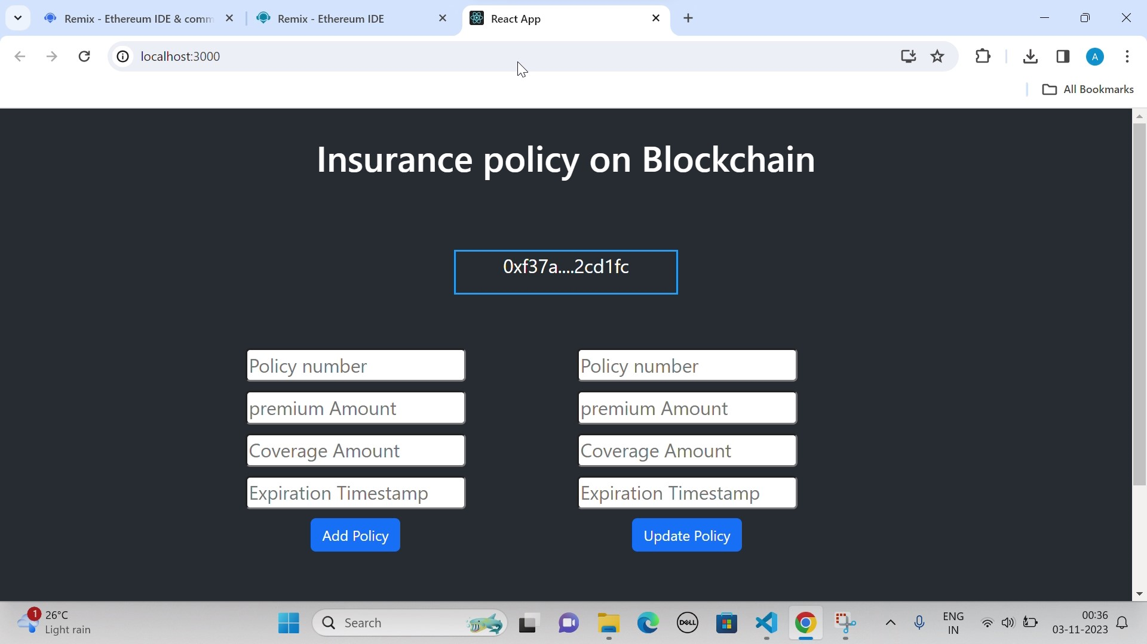

**ADVANTAGES AND DISADVANTGES OF FARMER INSURANCE CHAIN:**

**10.1 Advantages of Farmer Insurance Chain:**

* **Risk Mitigation:** Farmer insurance helps protect farmers from unexpected losses due to factors like extreme weather events, crop diseases, or market price fluctuations. As these risks persist, the demand for such insurance is likely to increase.
* **Technology Integration:** The use of technology, including satellite data, IoT, and blockchain, can improve the accuracy of assessing and processing claims. This integration is expected to enhance the efficiency and effectiveness of farmer insurance.
* **Government Initiatives:** Many governments support farmer insurance programs to safeguard the agricultural sector, which is vital for food security. These initiatives may drive further growth in this sector.
* **Customization:** Tailoring insurance products to the specific needs of different types of farmers (e.g., smallholders, commercial farmers) and crops can create new opportunities for insurance providers.
* **Sustainability:** There is a growing emphasis on sustainable and climate-resilient agriculture. Insurance can play a role in encouraging sustainable practices and reducing the environmental impact of farming.
* **Data Analytics:** Advanced data analytics can help insurance providers better understand and predict agricultural risks, allowing for more accurate pricing and risk assessment.
* **Microinsurance:** Offering microinsurance to small-scale farmers can be a significant growth area, helping those with limited resources access coverage.
* **International Expansion:** As global trade in agricultural products continues to grow, there may be opportunities for insurance providers to expand internationally to cover farmers in different regions.
* **Public-Private Partnerships:** Collaborations between governments, insurers, and NGOs can lead to innovative insurance solutions that benefit both farmers and the insurance industry.

It's essential to adapt to changing market dynamics and regulatory environments to tap into the future potential of farmer insurance chains.

**10.2 Disadvantages of Farmer Insurance Chain:**

While farmer insurance chains offer many advantages, they also come with certain disadvantages and challenges:

* **Premium Costs:** Insurance premiums can be expensive for some farmers, particularly smallholders, making it a financial burden.
* **Administrative Complexity**: Insurance can involve complex paperwork and administrative processes, which may deter some farmers from participating.
* **Moral Hazard:** Some farmers may take on more risks because they believe insurance will cover their losses, potentially leading to more reckless agricultural practices.
* **Adverse Selection:** Insurance programs may attract riskier farmers, leading to higher costs and premiums for the insurance provider.
* **Limited Coverage:** Some insurance policies may not cover all types of risks or may have exclusions that limit their effectiveness.
* **Delayed Payouts:** Farmers might face delays in receiving insurance payouts, especially in the case of bureaucratic inefficiencies or disputes with insurance providers.
* **Limited Access:** Farmers in remote or underserved regions may have limited access to insurance products and information.
* **Cost-Benefit Ratio:** In some cases, the cost of insurance premiums may outweigh the potential benefits, particularly for farmers with low-value crops.
* **Dependence on External Factors:** Insurance depends on external factors like the reliability of weather data, which can sometimes be inaccurate, affecting the accuracy of risk assessments.
* **Market Distortion:** Government subsidies and interventions in insurance programs can lead to market distortions and inefficiencies.
* **Ethical Concerns:** There are ethical considerations, such as whether insurance companies are profiting from the misfortune of farmers.
* **Climate Change Uncertainty:** Climate change introduces additional uncertainties in agriculture, making it challenging to accurately assess and price risks.
* **Limited Trust:** Some farmers may be skeptical of insurance providers or have a lack of trust in the insurance industry.

It's essential for policymakers, insurance providers, and farmers to address these disadvantages and work towards creating farmer insurance systems that are more equitable, affordable, and effective in reducing the financial vulnerabilities of agriculture.

**CONCLUSION:**

In this report, we have explored the transformative potential of implementing blockchain technology within the context of farmer insurance. The adoption of blockchain technology offers numerous advantages for the entire insurance chain within the agricultural sector.

Blockchain technology provides a secure and transparent platform for recording, verifying, and sharing data. By leveraging smart contracts, it allows for the automation of insurance processes, reducing the administrative burden and minimizing the risk of fraud. This creates a streamlined and efficient system that benefits both insurance providers and farmers. Furthermore, blockchain's decentralized nature enhances trust among all stakeholders involved, from insurers to farmers. With data immutability and transparency, trust is established in a trust-deficit industry, leading to improved relationships and, ultimately, more inclusive access to insurance services for small-scale and marginalized farmers.

The implementation of blockchain technology in farmer insurance can significantly reduce operational costs, expedite claims processing, and ensure that funds reach the intended beneficiaries swiftly. It also opens up opportunities for microinsurance and parametric insurance solutions, making insurance more accessible and affordable for farmers in need.

In conclusion, the integration of blockchain technology into the farmer insurance chain is a promising and innovative solution that has the potential to revolutionize the agricultural insurance sector. It addresses various pain points and inefficiencies in the current system, ultimately improving the resilience of farmers, ensuring food security, and driving sustainable agricultural practices.

As this technology continues to evolve and mature, it is crucial for stakeholders in the agricultural and insurance industries to collaborate, adapt, and embrace these changes for the betterment of the entire ecosystem. The path forward involves not only technological advancements but also regulatory support, education, and the commitment of all parties to create a more resilient and inclusive insurance system for our farmers.

The farmer insurance chain under blockchain technology represents a promising step toward a more equitable and efficient agricultural insurance landscape, empowering farmers and safeguarding their livelihoods for a more secure and sustainable future.

**FUTURE SCOPE:**

The future scope of the farmer insurance chain continues to hold significant promise. Here are some key points regarding its potential:

* **Digital Transformation:** Advancements in digital technology, including mobile apps and online platforms, can streamline insurance processes, making it easier for farmers to access and manage their insurance coverage.
* **Data Analytics:** Continued improvements in data analytics and artificial intelligence can enhance risk assessment, allowing insurance providers to offer more accurate and affordable policies.
* **Climate Change Adaptation:** As climate change poses greater risks to agriculture, there will be an increasing need for insurance products that address these challenges, such as coverage for extreme weather events and crop loss due to changing climate patterns.
* **Microinsurance Growth:** The expansion of microinsurance for small-scale and subsistence farmers in developing countries can provide financial protection to vulnerable agricultural communities.
* **Government Initiatives:** Governments worldwide may continue to support and even mandate farmer insurance as a means of bolstering food security and rural development.
* **Sustainable Agriculture Incentives:** Insurance products that encourage and reward sustainable and eco-friendly farming practices may become more prevalent as the importance of sustainability grows.
* **International Expansion:** Insurance providers may explore opportunities to expand internationally, covering farmers in different regions and countries.
* **Public-Private Partnerships**: Collaborations between governments, insurers, and NGOs can lead to innovative solutions, making insurance more accessible and beneficial for farmers.
* **Tailored Products:.** Customized insurance products for specific crops and farming practices may emerge to meet the diverse needs of agricultural producers

The evolving landscape of agriculture, combined with ongoing global challenges, underscores the importance of farmer insurance. To capitalize on the future scope, insurance providers should adapt to changing circumstances and continue to innovate in the services they offer to the farming community.

**APPENDIX:**

**SOURCE CODE:**

The source code of the project is given in the below drive link.

Source code link: <https://drive.google.com/drive/folders/10VGbch-kHhUKk1oQJevdqOmsvNeqaQN6>

**GITHUB LINK:**

[**https://github.com/AswinKrishna2002/Farmer-insurance-chain**](https://github.com/AswinKrishna2002/Farmer-insurance-chain)

**DEMONSTRATION VIDEO LINK:**

<https://drive.google.com/drive/folders/10VGbch-kHhUKk1oQJevdqOmsvNeqaQN6>